Hinduism, the world's oldest religion, has no beginning--it precedes recorded history. It has no human founder. It is a mystical religion, leading the follower to personally experience the Truth within, finally reaching the highpoint of mindfulness where man and God are one.
Hinduism has four main denominations--Saivism, Shaktism, Vaishnavism and Smartism.

Hinduism

.

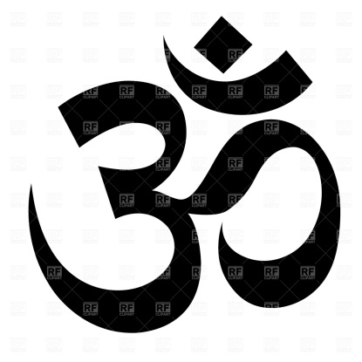
Hinduism: Number: 900 MILLION
Sacred Text: Vedras: Upanishads
Place of Worship: Mandir or temple
Symbol: Aum

Hindus believe that the universe undergoes endless cycles of creation, preservation and dissolution.
- Hindus believe in karma, the law of cause and effect by which each individual creates his own destiny by his thoughts, words and deeds.
- Hindus believe that the soul reincarnates, evolving through many births until all karmas have been resolved, and moksha, liberation from the cycle of rebirth, is attained. Not a single soul will be deprived of this destiny.
- Hindus believe in temple worship, rituals, sacraments and personal devotionals
- Hindus believe in meditation.
- Hindus believe that all life is sacred, to be loved and revered, and therefore practice ahimsa, non-injury, in thought, word and deed.
- Hindus believe that no religion teaches the only way to salvation above all others, but that all genuine paths are facets of God's Light, deserving tolerance and understanding.
