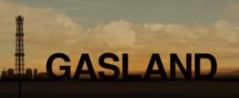

TASK: After viewing the movie Gasland answer the following questions.

- What is this movie about?
______________________________________________________________________________________________________________________________________________________________________________________________________________________________________________________
- Who has made the movie? Would you consider it to be a reliable and non-biased view?
____________________________________________________________________________________________________________________________________________________________________

- Name the country where this occurred? _________________________________

- What can we in Australia learn from this movie?
____________________________________________________________________________________________________________________________________________________________________
- After viewing this film would you be more conscious to look into evidence or would you just take the money. ___________________________________________________________

