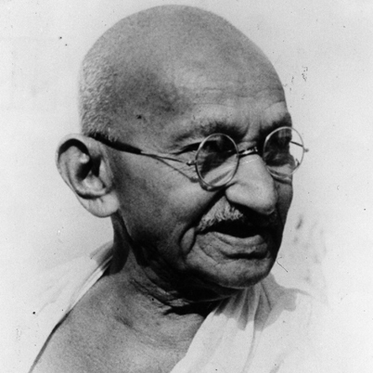

**Mahatma Gandhi**

**Passion**

**for**

**Justice**

**Born 1869**

**Assassinated 1947**

**COURAGE**

LEADER

**Walk**

**Across**

**India**

**In**

**protestr**

**He aimed to alleviate poverty, liberate women and put an end to caste discrimination, with the ultimate objective being self-rule for India**.

**He helped poor farmers and labourers protest oppressive taxation and discrimination**

Hunger Strikes as an alternative to violence

**FAITH FILLED  
PRAYERFUL**

**Peacemaker**